|  |  |  |
| --- | --- | --- |
| ACAD-DI-86 | **Lab Manual** | Academic Year: 2023-24 |
| Rev : 01 | Semester: II |
| Date: 02.04.2021 |

**Subject:** Operating Systems Lab (BTCOL406)

**List of Experiments**

|  |  |
| --- | --- |
| **Exp. No.** | **Name of Experiments** |
| 01 | Hands on Unix Commands. |
| 02 | Shell Script programming using the commands grep, awk, and sed. |
| 03 | Implementation of various CPU scheduling algorithms (FCFS, SJF). |
| 04 | Concurrent programming; use of threads and processes, system calls (fork and v-fork). |
| 05 | Study Pthreads and implement the following: write a program which shows a performance. |
| 06 | Implementation of Producer-Consumer problem. |
| 07 | Implementation of various page replacement algorithms (FIFO, LRU). |
| 08 | Implementation of various memory allocation algorithms, (First fit, Best fit and Worst fit). |
| 09 | Implementation of Bankers algorithm. |
| 10 | Scheduling algorithms (FCFS, SCAN, SSTF, C-SCAN). |

**Experiment No: 01**

**Aim: Hands on Unix Commands.**

**Objectives:** To study and implement various UNIX Commands.

**Theory:**

**UNIX:**

It is a multi-user operating system. Developed at AT & T Bell Industries, USA in 1969. Ken Thomson along with Dennis Ritchie developed it from MULTICS (Multiplexed Information and Computing Service) OS. By1980, UNIX had been completely rewritten using C language.

**LINUX:**

It is similar to UNIX, which is created by Linus Torualds. All UNIX commands works in Linux. Linux is open source software. The main feature of Linux is coexisting with other OS such as windows and UNIX.

**STRUCTURE OF A LINUX SYSTEM:**

It consists of three parts.

a) UNIX kernel

b) Shells

c) Tools and Applications

**UNIX KERNEL:**

Kernel is the core of the UNIX OS. It controls all tasks, schedule all Processes and carries out all the functions of OS. Decides when one programs tops and another starts.

**SHELL:**

Shell is the command interpreter in the UNIX OS. It accepts command from the user and analyses and interprets them.

**CONTENT:**

1. **gedit:** Use to open a text editor to create the C source code.

gedit

Ex. gedit

**Enter the C source code below:**

int main()

{

    int A, B, sum = 0;

    printf("Enter two numbers A and B: \n");

    scanf("%d%d", &A, &B);

    // Calculate the addition of A and B

    // using '+' operator

    sum = A + B;

    // Print the sum

    printf("Sum of A and B is: %d", sum);

    return 0;

}

Save the program and close the editor window.

1. **gcc -o filename filename.c :** Use to compile a C program.

Ex.

gcc -o sum sum.c

This command will invoke the GNU C compiler to compile the file sum.c and output (-o) the result to an executable called sum.

1. **./filename :** Use to run a C program:

Ex. ./sum

This should result in the output

Enter two numbers A and B:

4 5

Sum of A and B is: 9

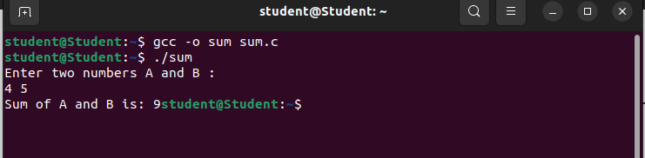

1. **date:** used to check the date and time

Syntax: $date [+format]

**Ex.** $date

**Output:**

Wednesday 29 March 2023 02:02:06 PM IST

**List of Format specifiers used with date command:**

**%D: Display date as mm/dd/yy.**

%d: Display the day of the month (01 to 31).

%a: Displays the abbreviated name for weekdays (Sun to Sat).

%A: Displays full weekdays (Sunday to Saturday).

%h: Displays abbreviated month name (Jan to Dec).

%b: Displays abbreviated month name (Jan to Dec).

%B: Displays full month name(January to December).

%m: Displays the month of year (01 to 12).

%y: Displays last two digits of the year(00 to 99).

%Y: Display four-digit year.

%T: Display the time in 24 hour format as HH:MM:SS.

%H: Display the hour.

%M: Display the minute.

%S: Display the seconds.

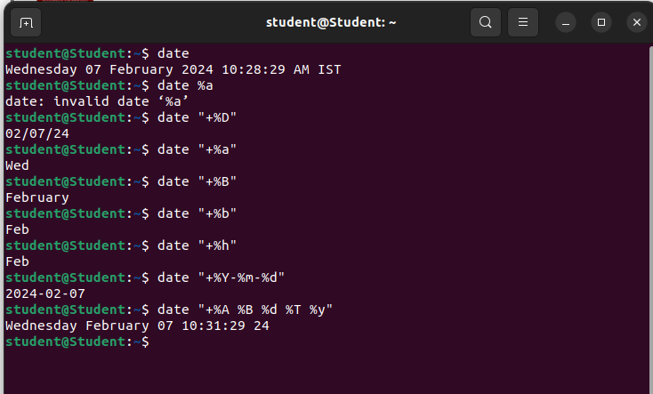

**5) cal:** used to display the calendar.

Syntax:$cal

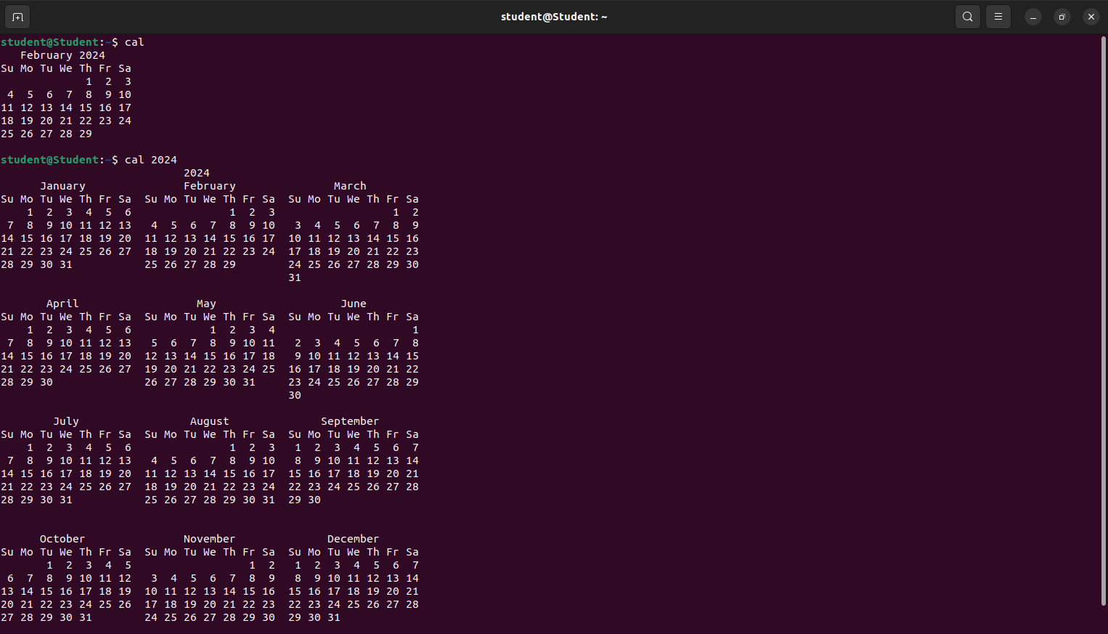

**6) echo** : used to print the message on the screen.

Syntax:$echo “text”

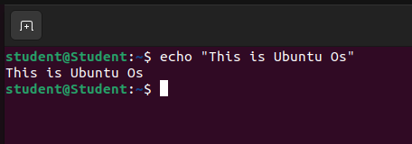

**7) ls** : used to list the files.

Syntax:$ls

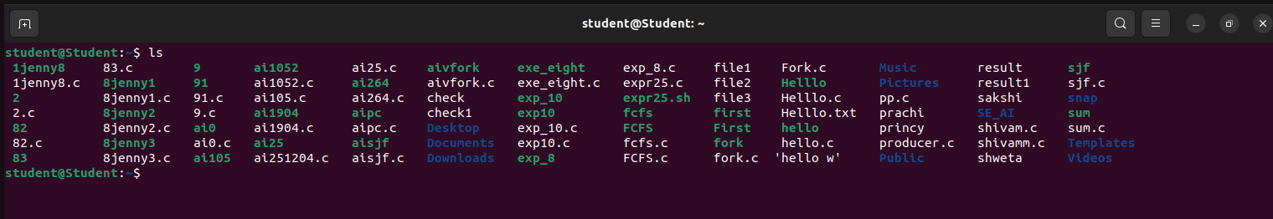

**8) who & whoami** –it displays data about all users who have logged into the system currently. The next command displays about current user only.

Syntax:$who

student tty2 2023-03-29 13:54 (tty2)

$whoami

Student

**9) uptime:** tells you how long the computer has been running since its last reboot or power-off.

Syntax:$uptime

14:36:39 up 43 min, 1 user, load average: 0.71, 0.66, 0.63

**10) uname:** it displays the system information such as hardware platform, system name and processor, OS type.

Syntax:$uname

Linux

**11) hostname** –displays and set system host name

Syn:$ hostname

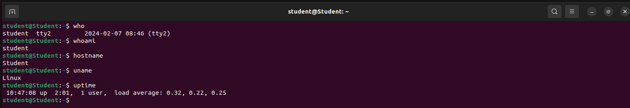

**12) bc** –stands for “best calculator”

Syntax:$bc

10/2*3

15

Quit

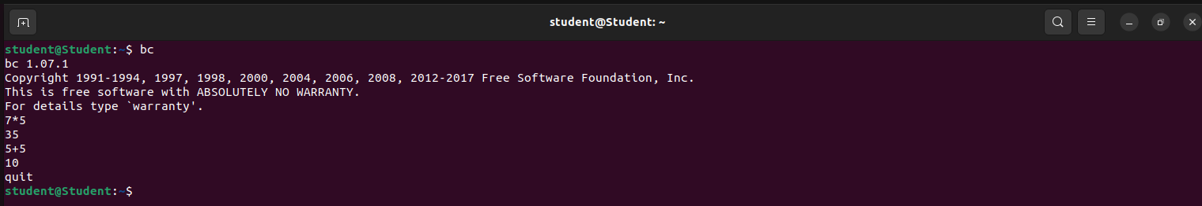

**13) $cat>filename** : This command is used to create a file.

Syntax: $cat>filename

**14) $cat filename** : This command is used to view a file

Syntax:$cat filename

**15) $cat>>filename** : this command is used to add text to an existing file:

Syntax:$cat>>filename

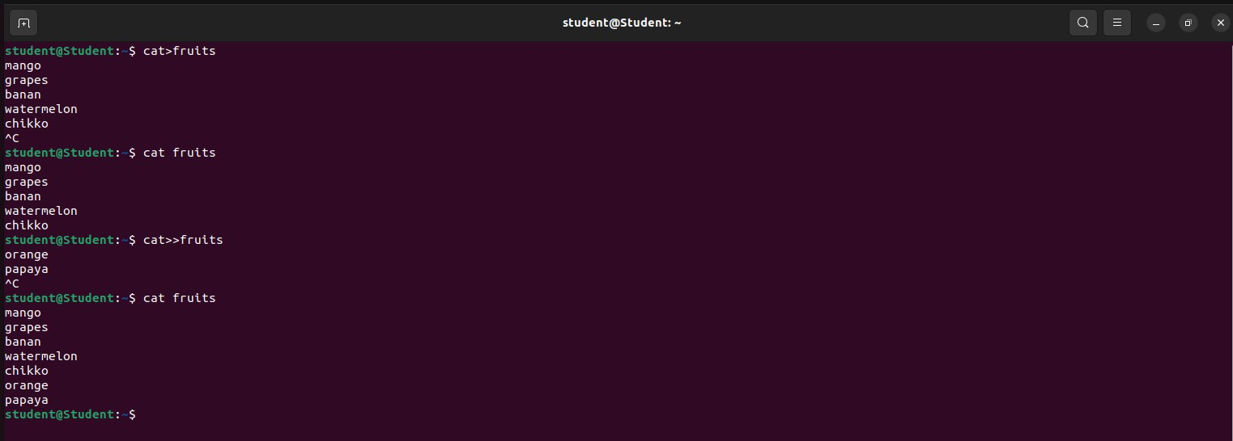

**16) Concatenate:**

Syn:$cat file1 file2>file3

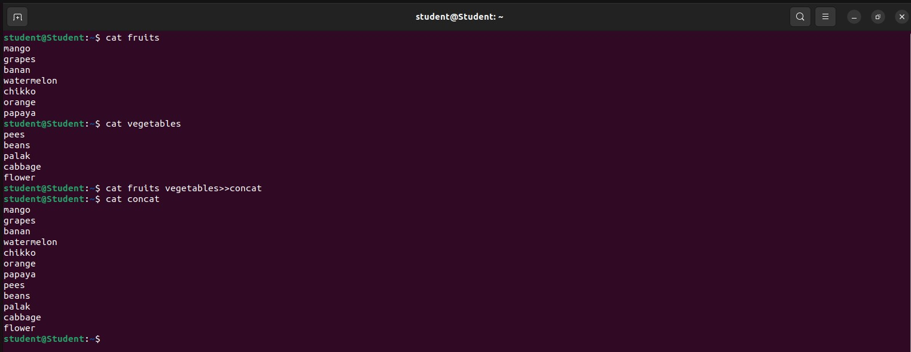

**17) rm–**deletes a file from the file system

Syn:$rm filename

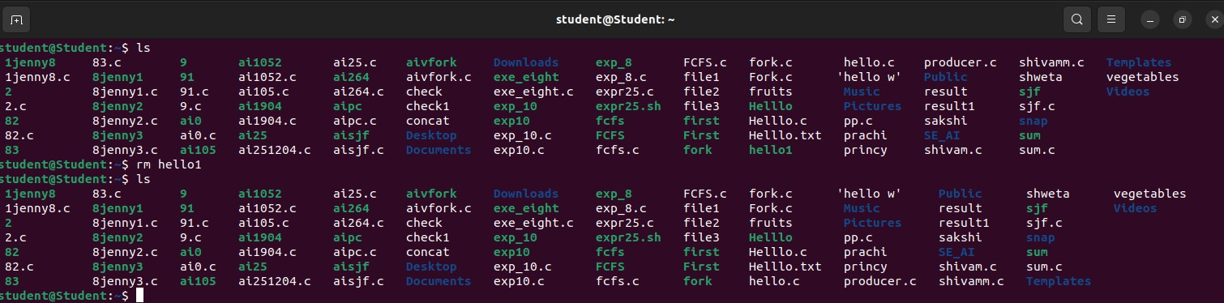

**18) cp**–copies the files or directories

Syn:$cp source file destination file

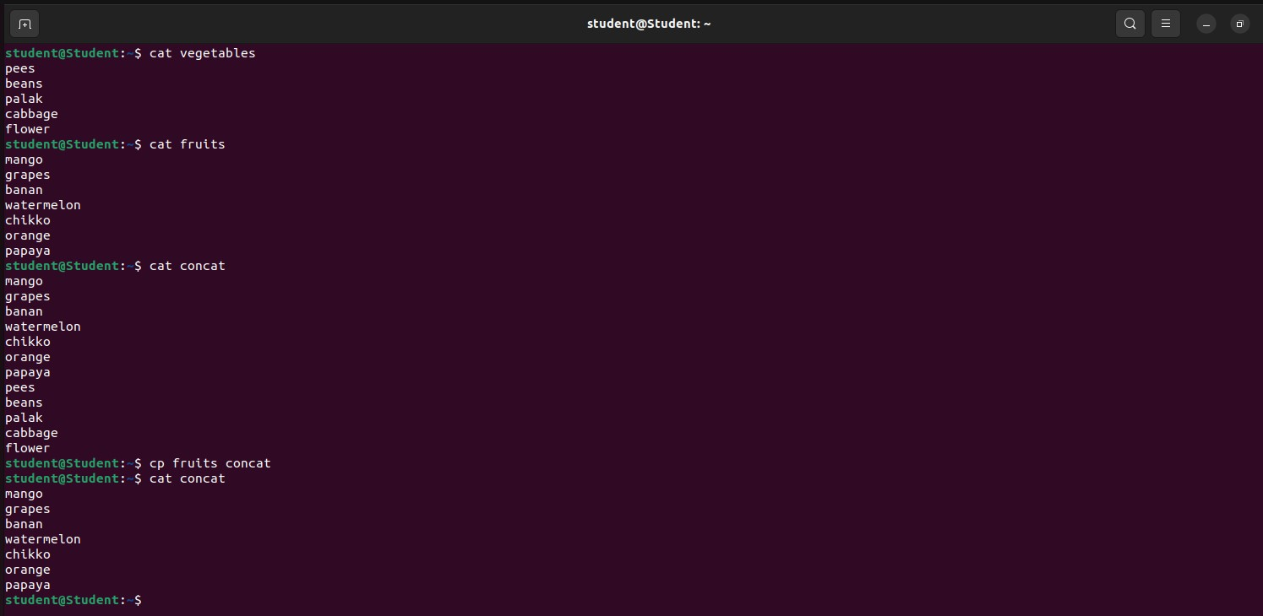

**19) mv**–to rename the file or directory

syn:$mv old file new file

Eg:$mv abc xyz

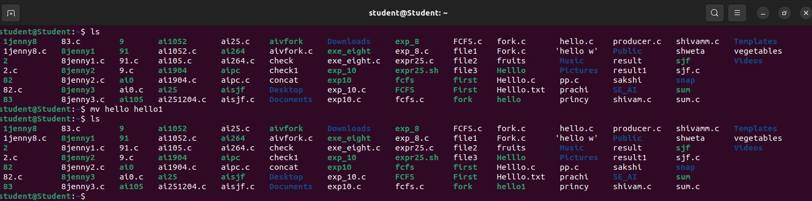

**20) head**–displays10 lines from the head(top) of a given file

Syn: $head filename

Eg: $head concat

To display the top two lines:

Syn: $head -2 concat

**21) tail**–displays last 10 lines of the file

Syn: $tail filename

Eg: $tail -2 concat

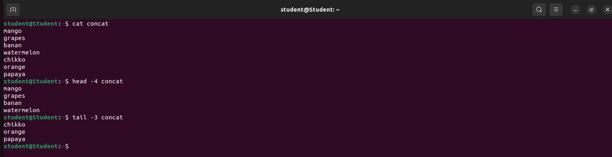

**22) wc–**it counts the number of lines, words, character in a specified file(s)

$ wc state.txt

5 7 58 state.txt

